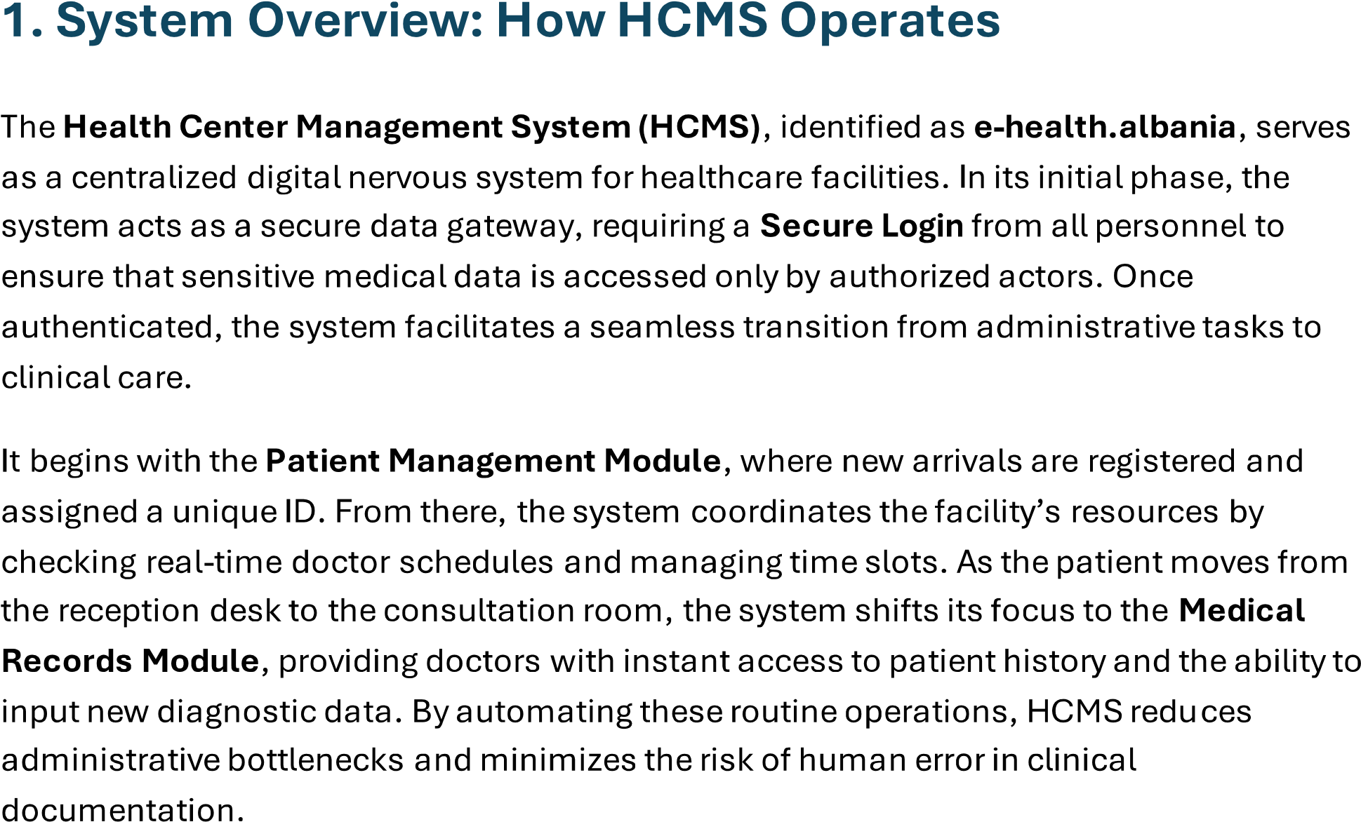
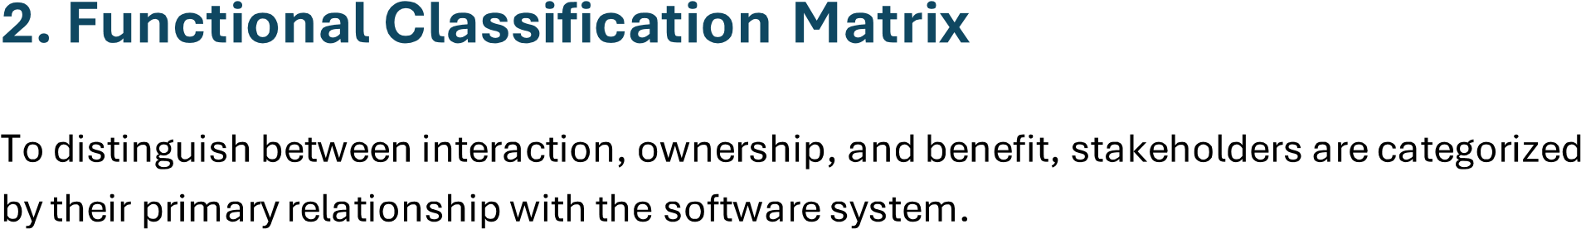

3. Health Center Management System (QSHMS)
The stakeholder analysis for QSHMS identifies four main groups of stakeholders who interact with or are affected by the system.
Operational stakeholders are the primary users of the system, including doctors, receptionists, nurses, and system administrators. They use the system daily to manage patients, appointments, medical records, and system operations.
Internal stakeholders include staff who support the organization, such as IT personnel, HR managers, accountants, and lab technicians. They do not directly use the system for patient care but rely on its data and functionalities for their work.
External stakeholders are individuals or organizations outside the healthcare center, such as patients, insurance companies, pharmacies, and external laboratories. They interact with the system through services like appointment booking, prescription processing, testing, and billing.
Executive stakeholders are strategic decision-makers, including directors, managers, and government authorities. Their focus is on system performance, legal compliance, security, and financial and organizational efficiency.
Overall, the QSHMS serves as a central platform that connects all these stakeholders, improving healthcare service management, operational efficiency, and the quality of patient care.

